Guide

Reproduction steps:
Link: https://5178057.app.netsuite.com/c.5178057/pos/main.ssp?whence=&n=2#login
Enter on SCIS -> Select Transaction History:
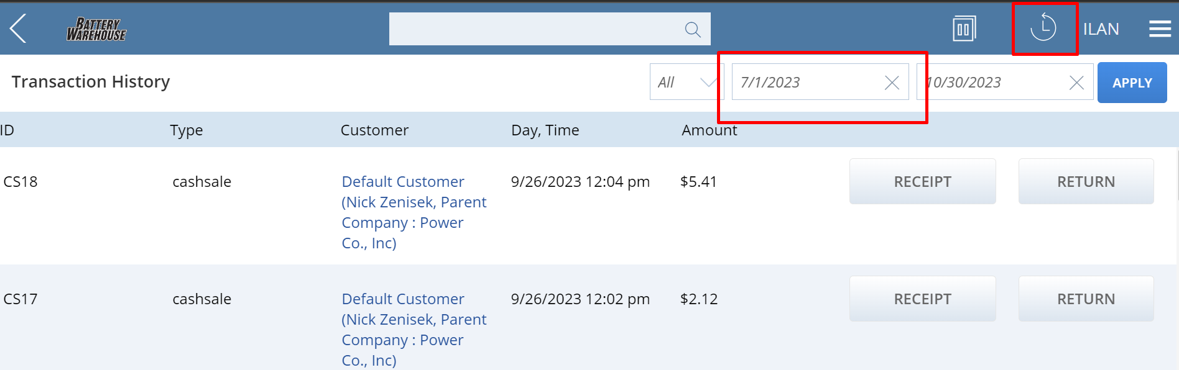
Then, change the date, and select receipt:
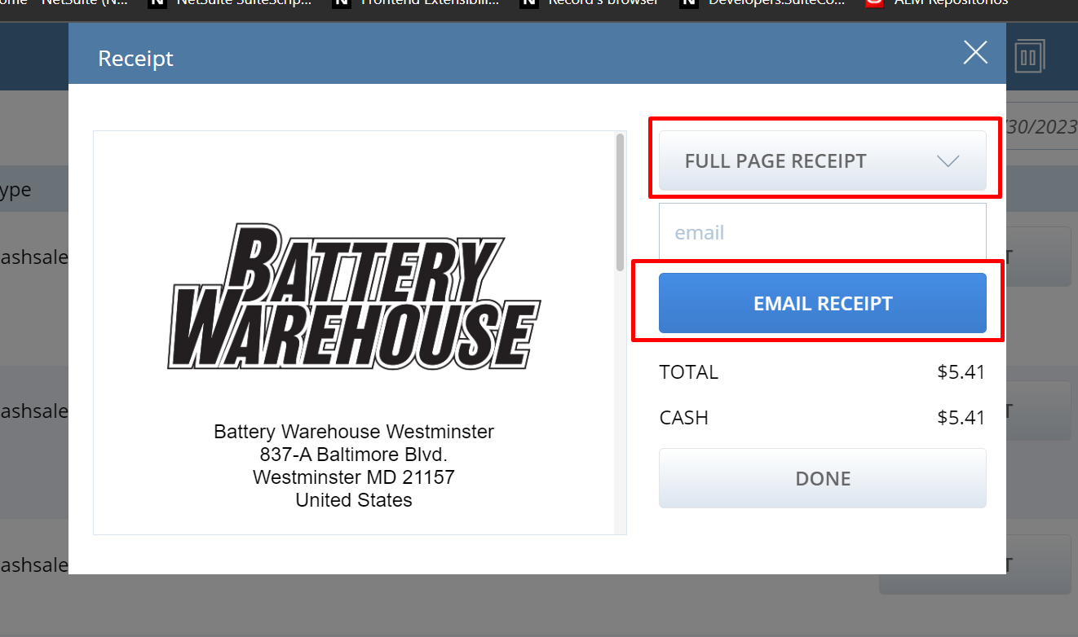
Select “Full page receipt” and then email the receipt, and you will get something they do not like now.

Search for EST13 -> press “Open Quote” -> Select “ILAN TEST TEMPLATES”:
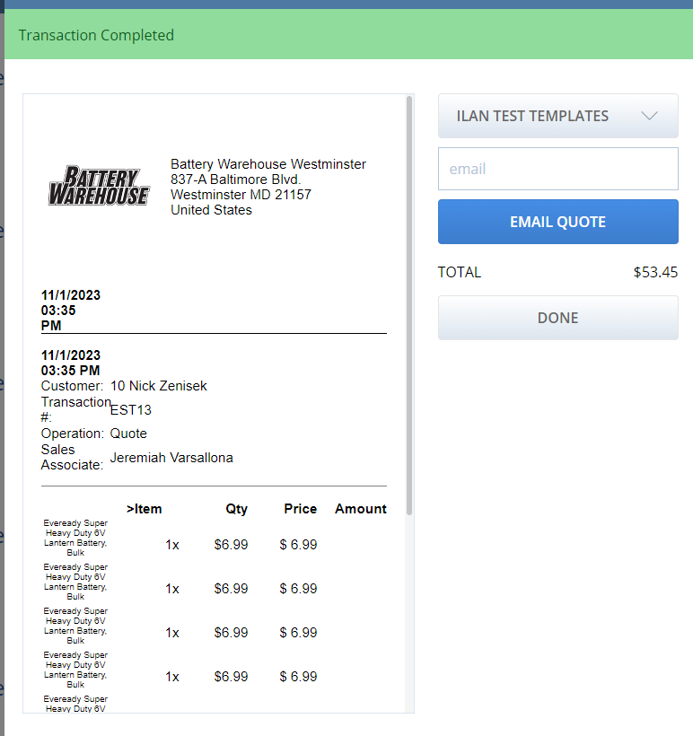
Fill up with email and send.

How do they want it to look
They want full page SCIS receipt to look like quote template:
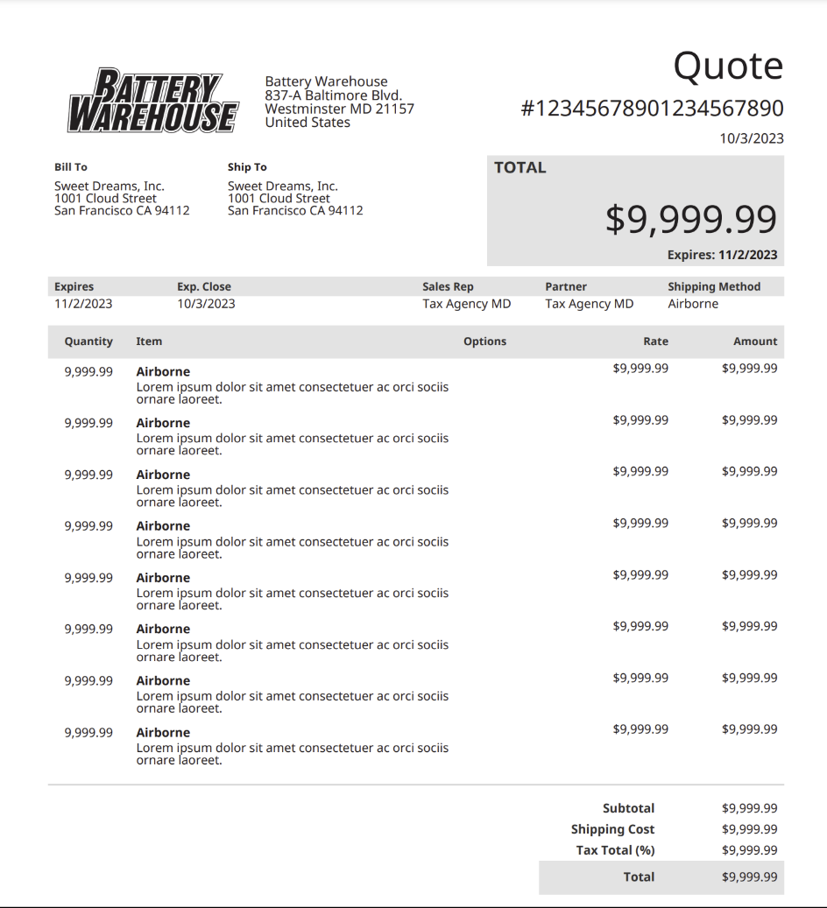
And they want to mix it with the PDF given on email (template is on this same folder here).
This template looking like is in: Customization -> Forms -> Advanced PDF Templates:
Custom Quote PDF/HTML Template (marked as preferred).
I can use this one to pull some data that I can reuse on my template.
(Ask the customer for a quote on SCIS to generate an example and make sure it’s this receipt template).
You can check:
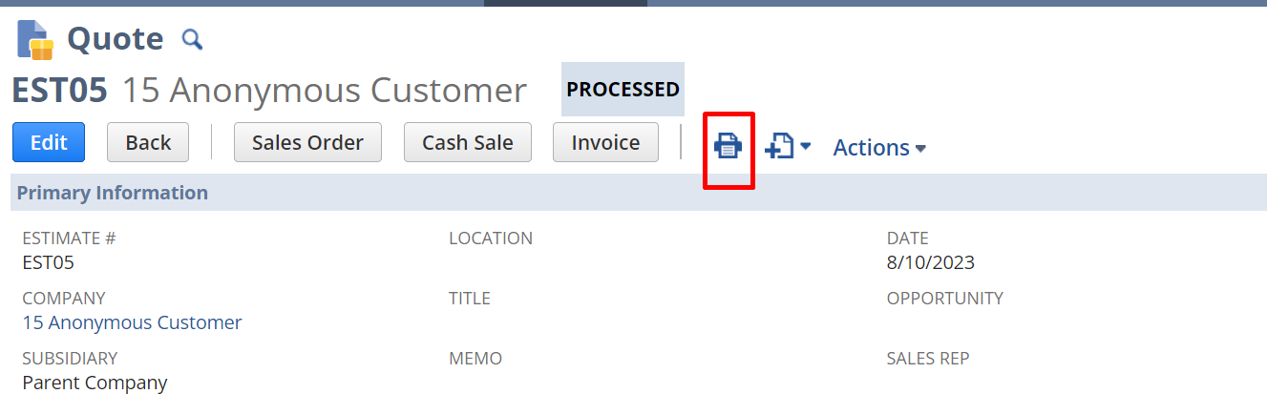
And prints the one

How is it currently looking and where can we make the changes to modify how it looks now
You can look which templates are assigned on Commerce -> In Store -> Receipt Templates and then you see that:
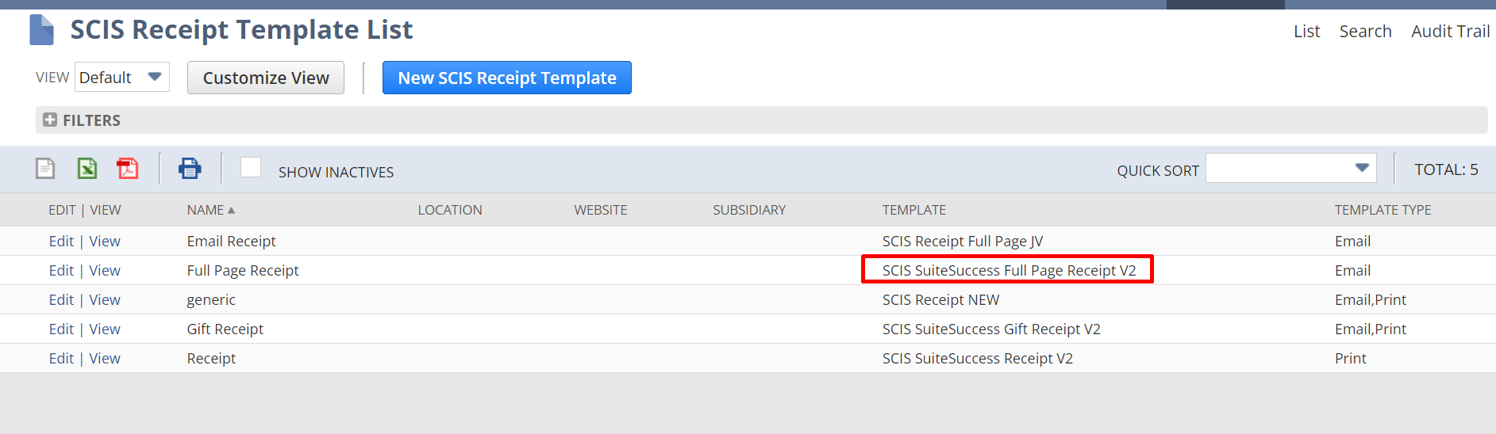
Full page receipt is “SCIS SuiteSuccess Full Page Receipt V2” and we will need to replace that one with the one the client wants.
Currently this full page receipt v2 prints (having followed all the repro steps):
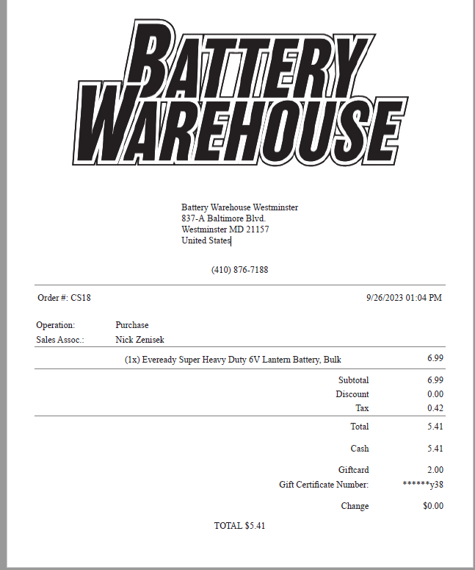
Notes:
Update Ilan’s template (SCIS ilan’s template): SCIS SuiteSuccess Full Page Receipt Ilan
Use as example Custom Quote PDF/HTML template.

- Add ship to ( take it from the quote) (pull it from customer default shipping because it’s linelevel, and it’s not filling up, fill it up with the bill to

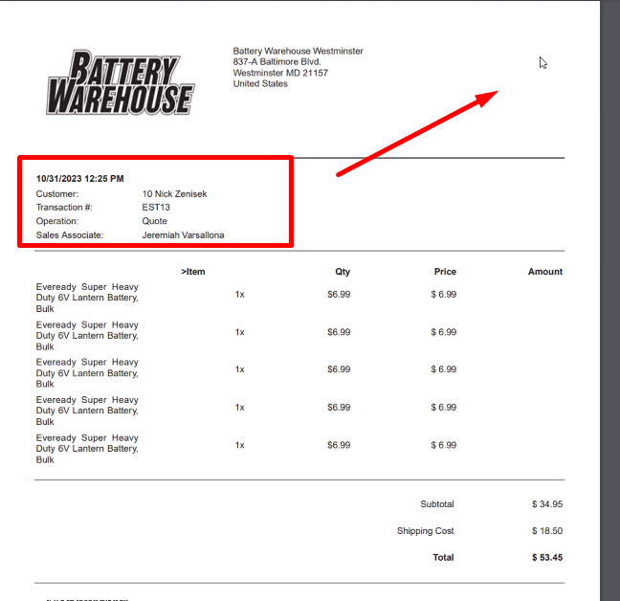

Move that red thing to the right.

How to test
Open SCIS

